**Project 5:**

**Traffic signal Light Controlling**

**Description**: In this project we will demonstrate how we can make 3 road signal traffic light using led . we have 3 led red , yellow and green . we construct them in the right way and make a automated traffic control signal. Red light means stop and yellow light meant ready to go and green light means go. Here we make 3 road light signal for safety traking and then will change automatically.

**Required Hardware:**

* Arduino Uno.
* Breadboard.
* Jumper wire.
* 9 LEDs.
* Resistor.
* USB type A/B.
* Push button

**LED**:

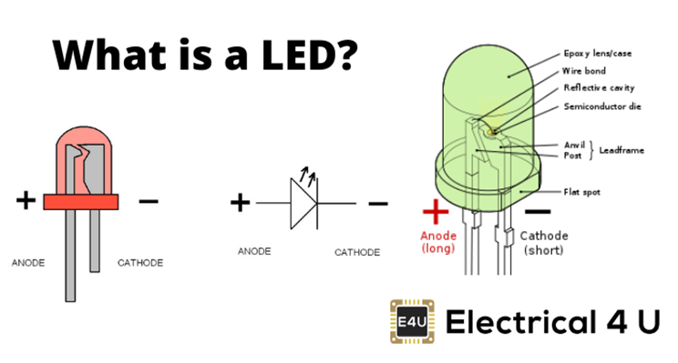

**Circuit Diagram:**

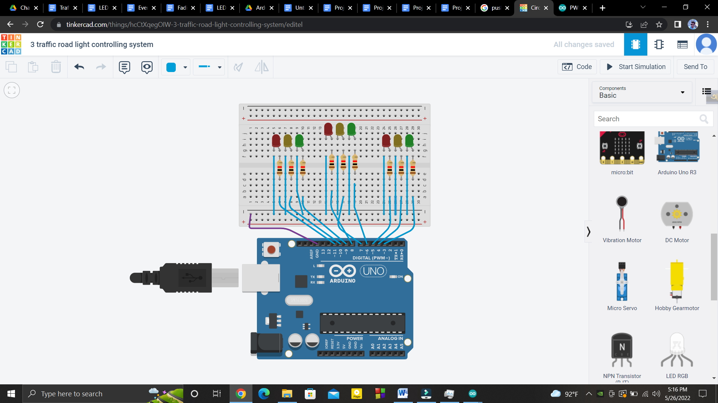

**Pin Configuration:**

1st signal :

* Green led connected to arduino’s pin 3.
* Yellow led connected to arduino’s pin 4.
* Red led connected to arduino’s pin 5.

2nd signal:

* Green led connected to arduino’s pin 6.
* Yellow led connected to arduino’s pin 7.
* Red led connected to arduino’s pin 8.

3rd signal:

* Green led connected to arduino’s pin 9.
* Yellow led connected to arduino’s pin 10.
* Red led connected to arduino’s pin 10.

**Code:**

| int sig1[]={3,4,5};  int sig2[]={6,7,8};  int sig3[]={9,10,11};  int dly1=5000;  int dly2=2000;  int dly3=5000;  int i;  void setup()  {  for(i=0;i<3;i++)  {  pinMode(sig1[i],OUTPUT);  pinMode(sig2[i],OUTPUT);  pinMode(sig3[i],OUTPUT);    }    }  void loop()  {  //1st road light signal  digitalWrite(sig1[2],HIGH);  digitalWrite(sig2[0],HIGH);  digitalWrite(sig3[0],HIGH);  delay(dly1);    digitalWrite(sig1[2],LOW);  for(i=0;i<3;i++) // blink the red led  {  digitalWrite(sig1[2],HIGH);  delay(1000);  digitalWrite(sig1[2],LOW);  delay(1000);  }  digitalWrite(sig1[1],HIGH);  delay(dly2);  digitalWrite(sig1[1],LOW);  for(i=0;i<3;i++) // blink the yellow led  {  digitalWrite(sig1[1],HIGH);  delay(1000);  digitalWrite(sig1[1],LOW);  delay(1000);  }    //2nd Road light Signal    digitalWrite(sig1[0],HIGH);  digitalWrite(sig2[2],HIGH);  digitalWrite(sig2[0],LOW);  digitalWrite(sig3[0],HIGH);  delay(dly1);  digitalWrite(sig2[2],LOW);  for(i=0;i<3;i++) // blink the red Led  {  digitalWrite(sig2[2],HIGH);  delay(1000);  digitalWrite(sig2[2],LOW);  delay(1000);  }  digitalWrite(sig2[1],HIGH);  delay(dly2);  digitalWrite(sig2[1],LOW);  for(i=0;i<3;i++) //blink the yellow Led  {  digitalWrite(sig2[1],HIGH);  delay(1000);  digitalWrite(sig2[1],LOW);  delay(1000);  }    //3rd road Light signal    digitalWrite(sig3[0],LOW);  digitalWrite(sig3[2],HIGH);  digitalWrite(sig1[0],HIGH);  digitalWrite(sig2[0],HIGH);  delay(dly1);  digitalWrite(sig3[2],LOW);  for(i=0;i<3;i++) //blink the red Led  {  digitalWrite(sig3[2],HIGH);  delay(1000);  digitalWrite(sig3[2],LOW);  delay(1000);  }  digitalWrite(sig3[1],HIGH);  delay(dly2);  digitalWrite(sig3[1],LOW);    for(i=0;i<3;i++) // blink the Yellow led  {  digitalWrite(sig3[1],HIGH);  delay(1000);  digitalWrite(sig3[1],LOW);  delay(1000);  }  digitalWrite(sig1[0],LOW);    } |
| --- |